XMUM Launches New Master's Programme in Semiconductor Technology
Published on July 7, 2025
GeneralDepartment of Physics
Xiamen University Malaysia (XMUM) has introduced a new Master's Programme in Semiconductor Technology, aimed at preparing skilled professionals to support the rapidly growing semiconductor industry.
This postgraduate programme combines theoretical foundations with practical training in semiconductor science and engineering. It is designed to meet the increasing global demand for expertise in semiconductor technology, which underpins key developments in digitalisation, electric vehicles, artificial intelligence, and other emerging technologies.
In line with Malaysia's New Industrial Master Plan (NIMP) 2030, the programme contributes to national efforts to position the country as a regional centre for semiconductor innovation and talent development. Graduates of the programme will be equipped to pursue careers in both academia and industry, as researchers, engineers, or educators.
The curriculum includes courses in semiconductor physics, materials science, device fabrication, manufacturing processes, and cleanroom operations. A strong emphasis is placed on analytical thinking, problem-solving, and hands-on experience through laboratory work, collaborative projects, and industry exposure.
The programme is suitable for graduates in physics, engineering, and related fields, as well as professionals seeking to build or transition their careers into the semiconductor sector. It also provides a solid foundation for those considering doctoral studies or leadership roles in research and development.
The first intake is scheduled to begin on 29 September 2025. Applications are now open. For more information on admission requirements, course content, and available scholarships, please visit www.xmu.edu.my.
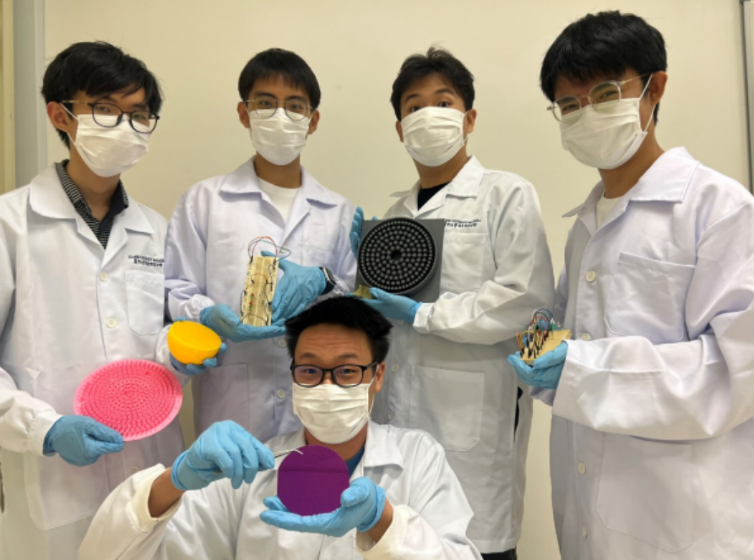
Students displaying prototyped fabrication of semiconductor and electronic products

